
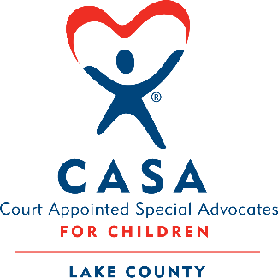

Dear Friend,

On October 30, 2026, Court Appointed Special Advocates (CASA) Lake County will hold its anniversary gala at Ravinia Festival. This is our largest fundraising event each year, raising roughly 20% of our annual operating budget, helping us continue to provide more than 600 Lake County children in the foster care system with a dedicated CASA Volunteer to advocate for their best interests.

You can help support our efforts by donating an item, gift basket, or gift certificate to be included in the silent or live auctions at our event. Your generosity will be proudly recognized to our 300 community leaders attending the gala as well as to more than 4,000 of our supporters electronically. You can help to make a profound and lasting impact in the life of a child.

Please fill out the enclosed donation form and return it with the envelope provided. If you have any questions, please contact Nicoleta Girloanta at 847-383-6260 x203 or by email at ngirloanta@casalakecounty.com to obtain more information. Thank you for helping us give these children what every child deserves—to be safe, protected, and loved.

With appreciation,
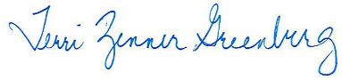
Terri Zenner Greenberg
Executive Director

Your contribution will be included in our 2026 gala’s silent or live auctions for 300 Chicagoland community leaders. Each year these auctions alone raise about $100,000 for our CASA children.

Learn more about our work at casalakecounty.com

